Document created: 24 March 2023
Document creator: Corporate web team

Vegetable guide

Vegetables are one of the healthiest foods you can eat. They are versatile and are part of many different dishes.
Biodiversity International scientists found a total of 1097 vegetable species grown worldwide.
There are 8 main types of vegetables, based on their edible parts.
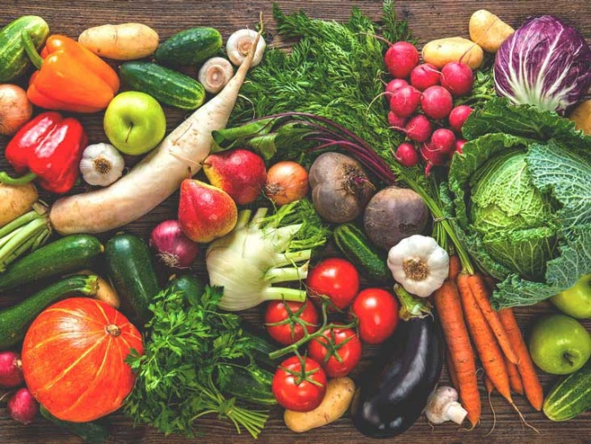

Root vegetables
Root vegetables grow underground and are sources of edible roots. They are full of valuable nutrients.
Depending on the type, a root vegetable can have a round or long shape and a fleshy texture. Common root vegetables include:

Carrots
Carrots are up to 88% water. You can eat them raw or cooked. Eating carrots has health benefits such as boosting your immune system and improving your eyesight. There are different types of carrots such as Chantenay and Nantes.

Chantenay carrots
Chantenay carrots are broad and stout. They are great for growing in shallow or heavy soils.

Nantes carrots
Nantes carrots have cylindrical roots and are medium length. They have a blunt end and a sweet taste.

Turnips
Experts believe that the turnip originated in middle and eastern Asia. When eaten raw turnips have a spicy taste but when cooked, they turn sweet.

How to grow turnips
Step 1: Dig a hole in the soil.

Step 2: Put a turnip seed in the hole and cover with soil.

Step 3: Water the turnip seed every 4 days for 3 weeks.

Step 4: At the end of the 3 weeks, dig up the turnip.

Bulb vegetables
Bulb vegetables grow just below the ground and are sources of edible bulbs. They have many layers and are aromatic, often used to add flavour when cooking.
Common bulb vegetables include:

Leeks
Leeks are a part of the lily family. They can reach up to 1.5 metres in height. Leeks are most used when cooking soups and stews.

Onions
Onions are some of the oldest vegetables, used by the first modern civilisations. You ca eat them raw or cooked. There are a range of different types of onions such as:

Spring onions
Spring onions are also known as scallions or green onions. Spring onions are very young onions that you harvest before the bulb has fully grown.

Shallots
Shallots are sweeter than regular red or white onions. Shallots can range in size, from under 1 inch to 1.5 inches in length.

Leafy vegetables
Leafy vegetables are also known as
- Greens
- Salad greens
- Vegetable greens
You can eat leafy vegetables raw or cooked. They are a good source of valuable nutrients such as fibre and protein.
Table 1: Fibre and protein content of leafy vegetables
Type of leafy vegetable | Amount of fibre in one cup (in grams) | Amount of protein in one cup (in grams)
Kale | 5 | 4
Collard greens | 3 | 2
Lettuce | 0.3 | None
Spinach | 4.3 | 0.86
Cabbage | 2 | 1
Bok choy | 1 | 1

Pod and seed vegetables
Pod and seed vegetables as also called legumes. They are types of vegetables that contain seeds inside a pod. Pod and seed vegetables include:
- Peas
- Beans
- Lentils
- Okra
- Peanuts
- Liquorice

Peas
There are 3 categories of pea:
- Snap pea
- Snow pea
- Shelling pea
Each of these categories have their own different varieties that you can grow at home. Each pea variety has its own growing needs and timeline.
Table 2: The planting needs and growing timeline of different varieties of peas
N/A means ‘Not applicable’. This means that there is no ideal planting season, and the peas can be grown during any season.
Variety of pea | Category of pea | Ideal planting season | Ideal amount of sunlight needed to grow | Number of days from planting to harvest
Sugar Ann | Snap pea | Spring/Summer | Full sunlight | 55
Mammoth Melting Sugar | Snow pea | Spring/Summer | Full sunlight | 65-75
Green Arrow | Shelling pea | Spring/Summer | Full sunlight | 65
Sugar Daddy | Snap pea | N/A | Full sunlight | 65
Dwarf Grey Sugar | Snow pea | Spring/Summer | Full sunlight | 66
Little Marvel | Shelling pea | Spring/ Summer | Full sunlight | 60
Wando | Shelling pea | Spring/Summer | Full sunlight | 68
Sugar Snap | Snap pea | Spring/Summer | Full sunlight | 66

For more information about growing peas and to buy your own pea seeds visit the Sow True Seed website.

Okra
Okra is originally from Africa. Many cuisines use okra, such as:
- Caribbean
- Creole
- Cajun
- Indian
Visit the BBC Good Food website for information on how to prepare and cook okra. You can also find a range of recipes that use okra.
Download the ‘Meals & More Recipe Book’ (PDF) from the Family action website for more vegetable recipe ideas.

Stem vegetables
Stem vegetables are plants that grow above ground and have edible stems, shoots, or stalks. The most popular stem vegetables are:
- Asparagus
- Celery
- Chard
- Bamboo shoots
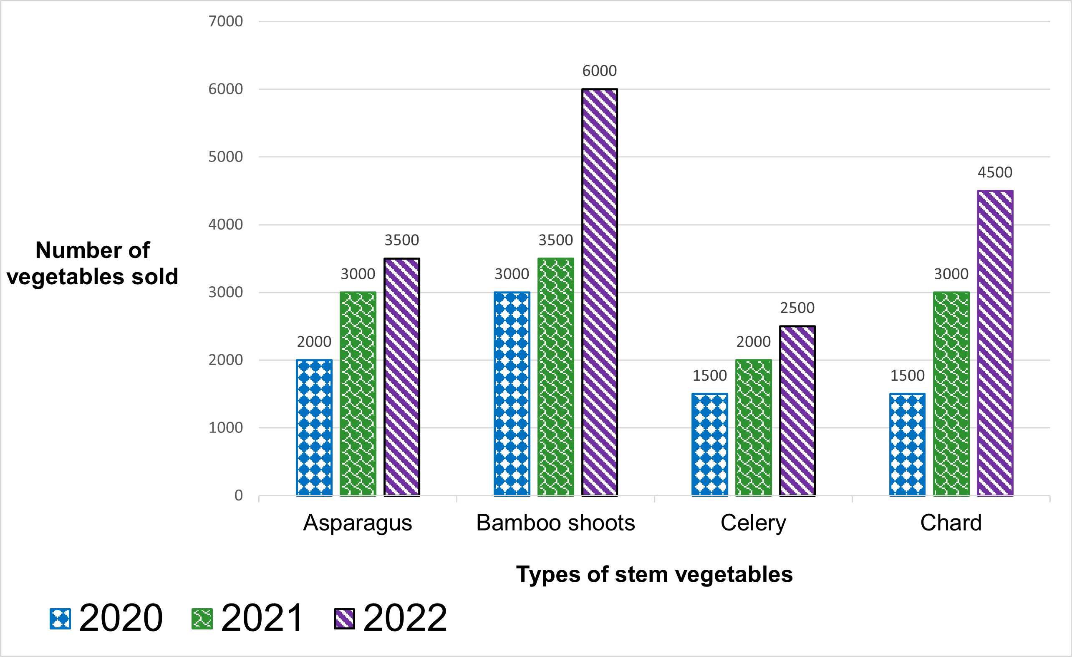
Figure 1: A bar chart showing the average number of stem vegetables sold in the years 2020, 2021 and 2022 in Norfolk
Figure 1 is a bar chart showing the average number of the most popular stem vegetables sold in Norfolk over 3 years:

Asparagus sales
- Year 2020: 2000 sales
- Year 2021: 3000 sales
- Year 2022: 3500 sales

Bamboo shoot sales
- Year 2020: 3000 sales
- Year 2021: 3500 sales
- Year 2022: 6000 sales

Celery sales
- Year 2020: 1500 sales
- Year 2021: 2000 sales
- Year 2022: 2500 sales

Chard sales
- Year 2020: 1500 sales
- Year 2021: 3000 sales
- Year 2022: 4500 sales

Tuber vegetables
Tuber vegetables grow underground on the root of a plant. Tuberous vegetables are usually high in starch and are a staple food in many parts of the world.
Commonly consumed tuber vegetables include:

Potato and sweet potato
Potatoes and sweet potatoes are easy to grow. Planting one seed potato will produce many potatoes to harvest.
Once you plant a seed potato or mother tuber, it will grow roots and stolons. Roots grow down into the ground. Stolons grow along the ground surface and can develop into new separate plants. They also grow into new tubers. These are the new potatoes that you can later harvest to eat.
The seed potato will also produce a plant that grows above the ground. The components of the plant are:
- A main stem
- Lateral stems that grow off the main stem
- Compound leaves that grow from the main stem
- Leaflets that grow from the lateral stems
- Flowers that grow at the top of the plant called inflorescence
- Fruit that grows from the flowers. This fruit is poisonous, and you should not eat it.
Figure 2: A diagram showing the components of the potato plant
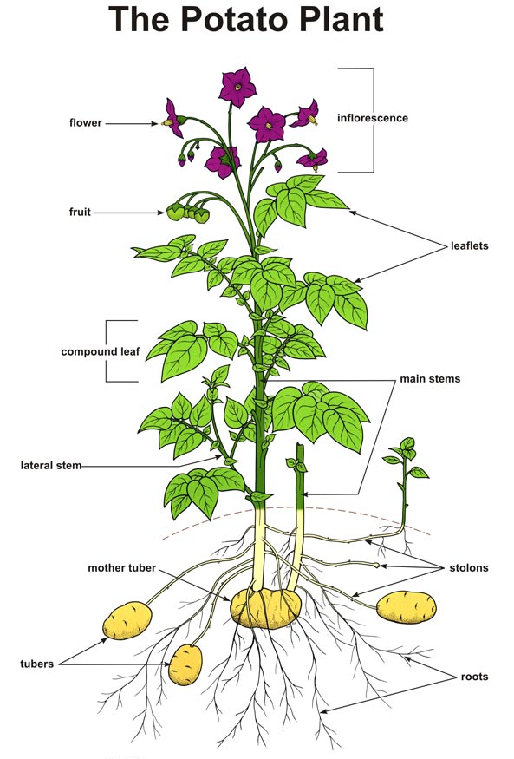

Jerusalem artichoke
Jerusalem artichokes are native to central North America. They also go by the names:
- Sunroot
- Sunchoke
- Topinambur
- Earth apple
- Wild sunflower
The plant of the Jerusalem artichoke can grow between 5-10 feet in height. They stand slightly taller than a typical sunflower plant.

Taro
Taro originates from Southeast Asia and India. It has a nutty flavour and is creamy in texture. Taro is high in fibre and eating it can help to control blood sugar.
Taro is very versatile. It features in many types of cuisines in both sweet and savoury recipes.
Table 3: Taro recipes
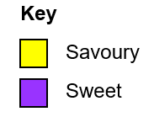

Name of recipe | Type of cuisine | Where you can find the recipe
Taro cake (savoury) | Chinese | Find the recipe for taro cakes on the Made with Lau website.
Taro fries (savoury) | American | Find the recipe for taro fries on the Chef Lola’s Kitchen website.
Tari with coconut milk (sweet) | Hawaiian | Find the recipe for taro with coconut milk on the Onolicious Hawaii website.
Taro root stew (savoury) | Egyptian | Find the recipe for taro root stew on the Matbakh website.
Taro ice cream (sweet) | Chinese | Find the recipe for taro ice cream on the Serious eats website.

Flower vegetables
Flower vegetables are plants that produce flowers. In most cases, flower vegetables are seasonal and often grown for their flower buds.
While these vegetables have roots, leaves, and stems, their flowers are usually the only edible part of the plant. Common flower vegetables are cauliflower and broccoli.

Cauliflower and broccoli
Cauliflower and broccoli are grown worldwide. Countries with the highest yield of these flower vegetables include:
- New Zealand
- Italy
- India
- China
- South America
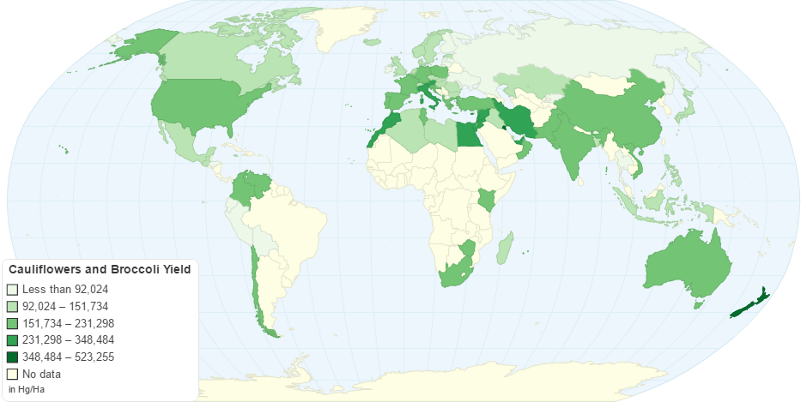
Figure 3: Map showing the yield of cauliflowers and broccoli in 2022 across the world
Both broccoli and cauliflower contain many beneficial nutrients. Depending on which nutrients you want to include in your diet you may choose to eat more of one than the other.
Table 4: Amount of nutrients found in 100g (grams) of broccoli versus 100g of cauliflower
Nutrient | Amount found in 100g of broccoli (in milligrams) | Amount found in 100g of cauliflower (in milligrams)
Vitamin E | 0.78 | 0.08
Vitamin K | No data | 1.15
Calcium | 47 | 22
Phosphorus | 89.2 | 48.2
Magnesium | 66 | 44
Fibre | 2.6 | 2
Choline | 18.7 | 44.3
Vitamin A | 1.09 | 0.14

Fruit vegetables
Fruit vegetables are plants that are fruits, but we treat them as vegetables for culinary purposes. Some produce you call fruits are vegetables and vice versa.
Common fruit vegetables include:
- Tomatoes
- Cucumbers
- Aubergines
- Squash
- Pumpkin
- Avocado
- Bell pepper

Tomatoes
The tomato was first eaten by the Aztecs as early as 700 AD. Tomatoes were not grown in Britain until the 1590s. Now they are very popular in the UK, eaten both raw and cooked in salad and pasta dishes for example.
Tomatoes are high in valuable nutrients. The nutrients that make up a single tomato are:
- 12% copper
- 14% fibre
- 16% vitamin K
- 24% biotin
- 34% vitamin C
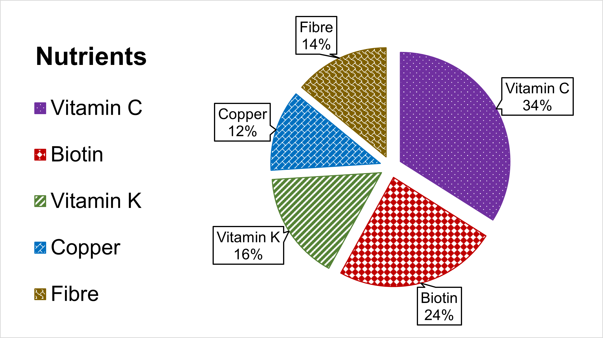
Figure 4: A pie chart showing the percentages of nutrients that make up a tomato

Pumpkins
Pumpkins are high in antioxidants. There are over 100 varieties of pumpkin.
Pumpkin growing season begins around mid-September and lasts throughout October and November.
There are many places in Norfolk that grow pumpkins in the autumn. You can visit and pick a pumpkin to use as a Halloween decoration.
The White House Farm in Norwich has a pumpkin patch. The address of the farm is Wroxham Road, Rackheath, Norwich, NR13 6LB.
Figure 5: Map showing the location of White House Farm in relation to Norwich city centre

Avocado
Avocados also go by the names:
- Alligator pear
- Butter fruit
They are high in fibre and are a popular breakfast food when eaten on toast.
Avocados have four parts:
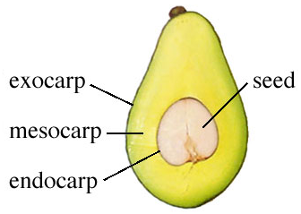

Conclusion
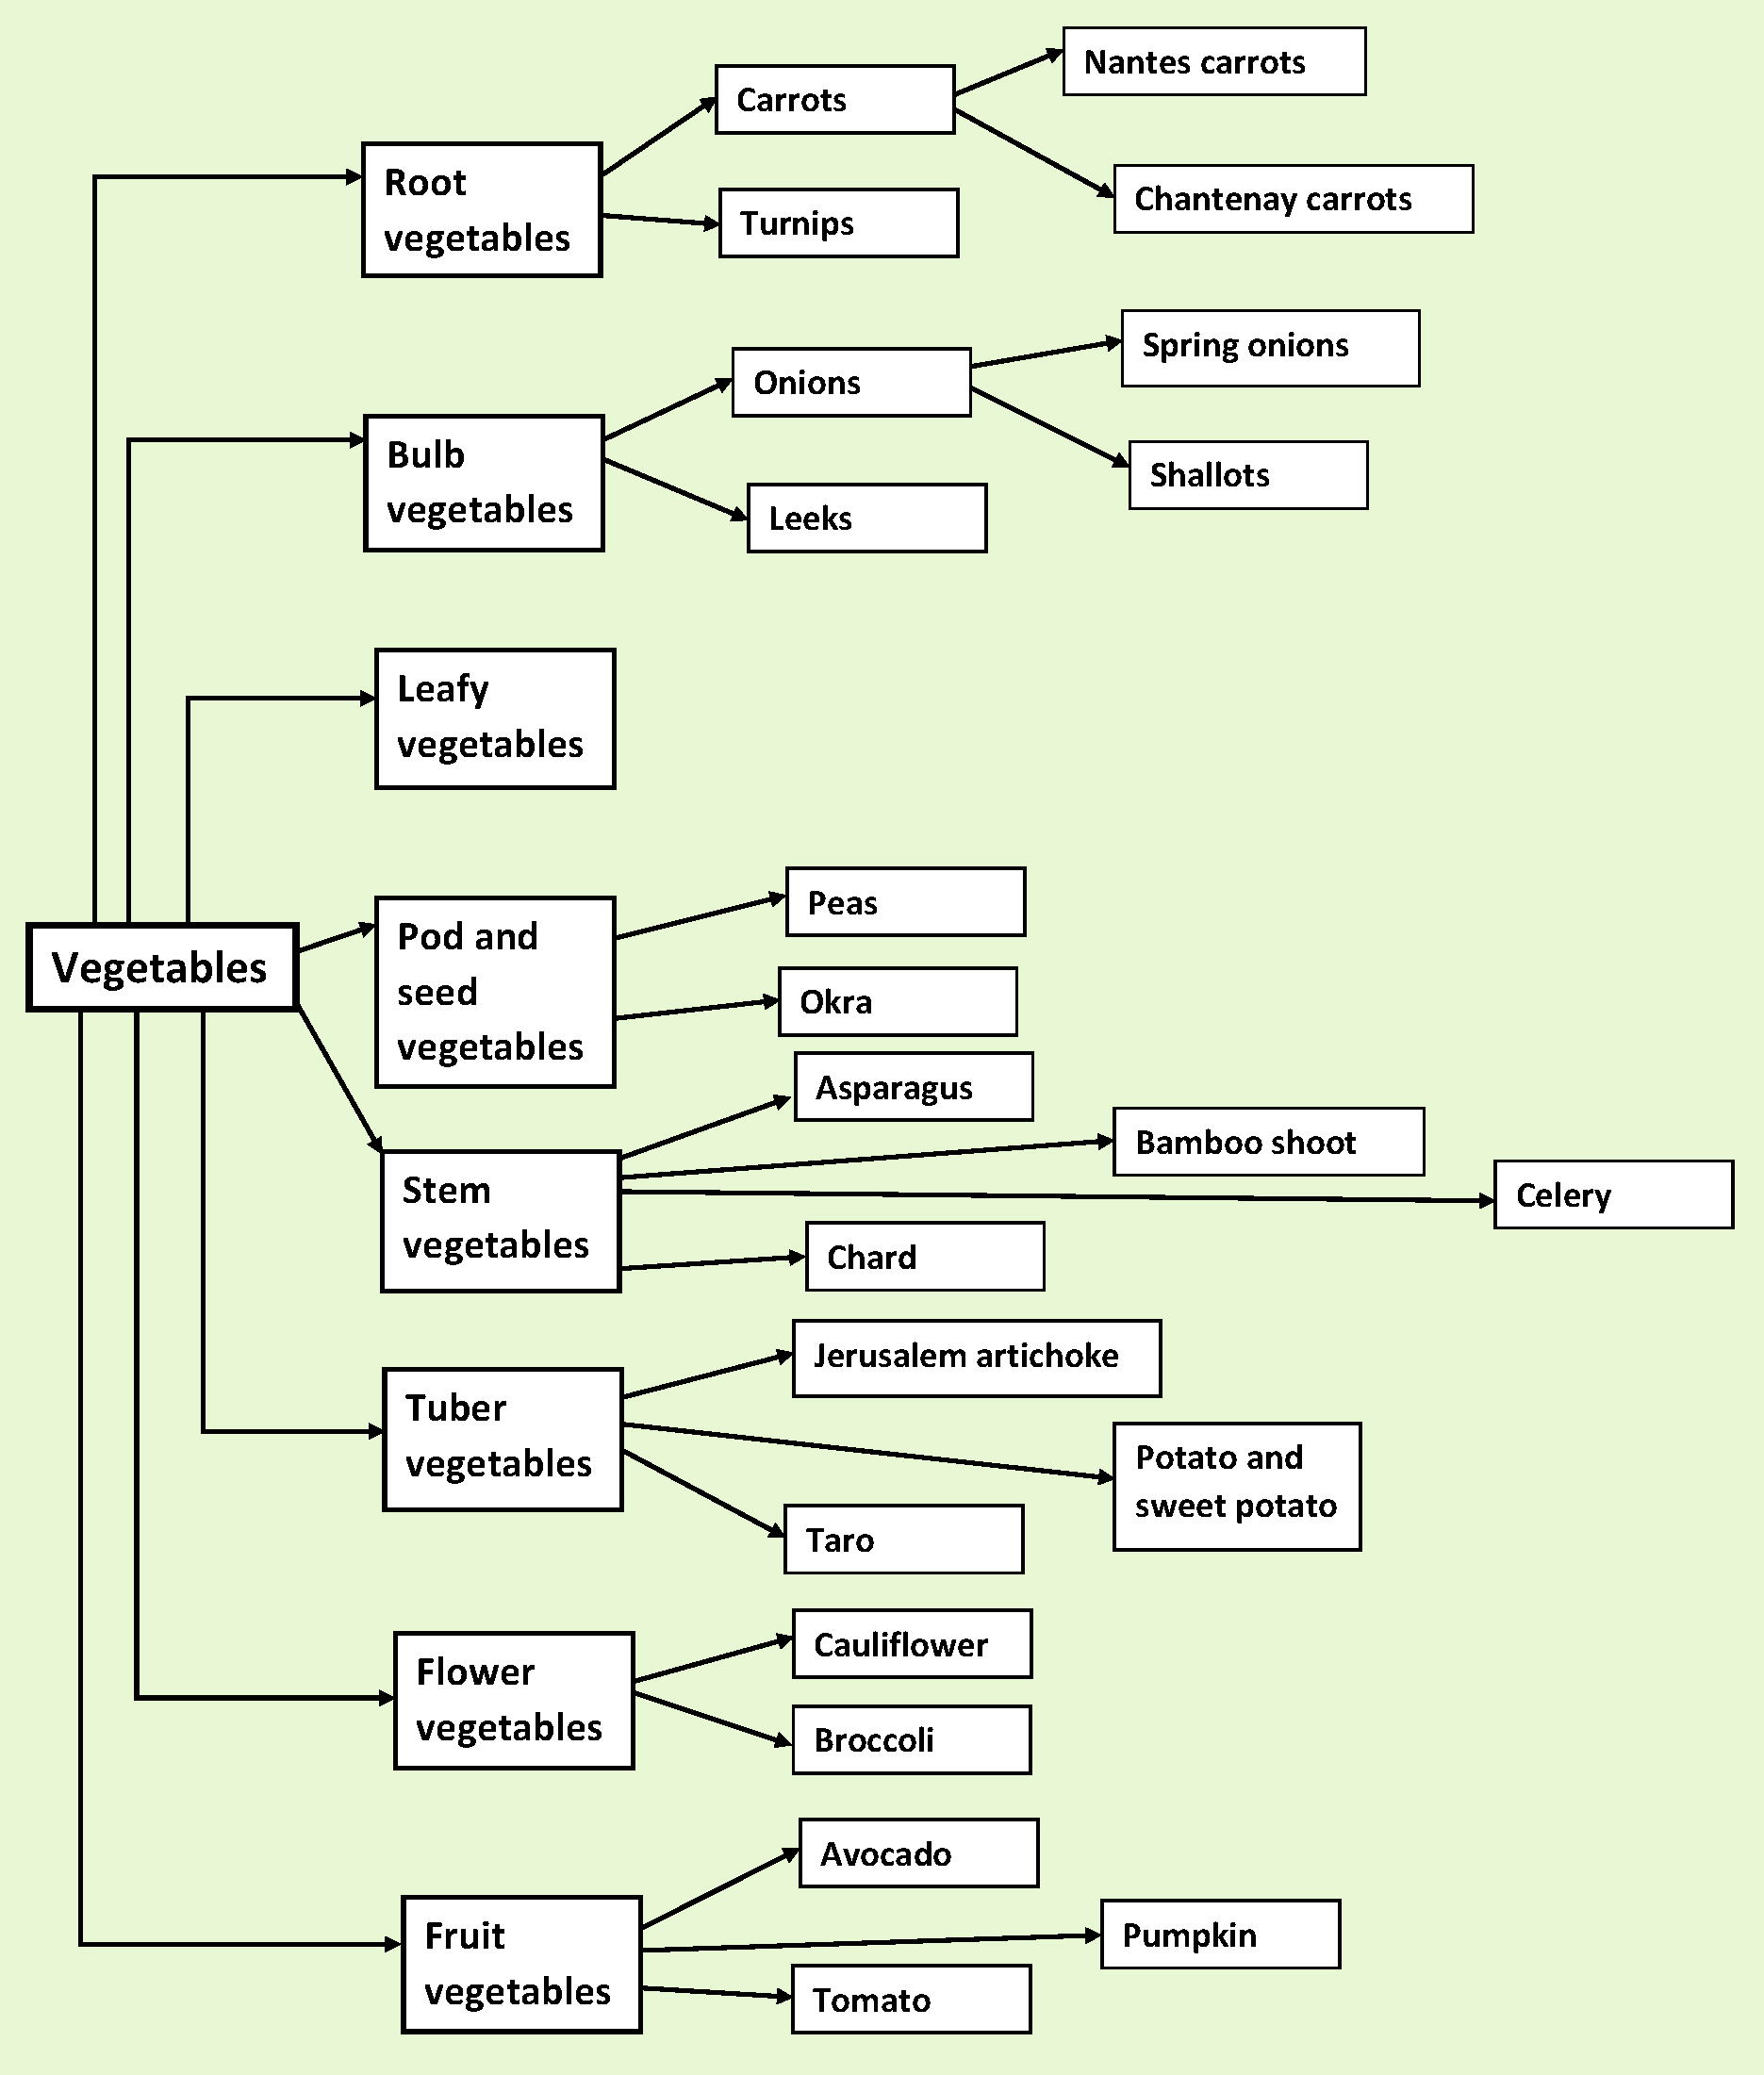
Vegetables are great. They are versatile to cook with and eat and have lots of nutrients.

