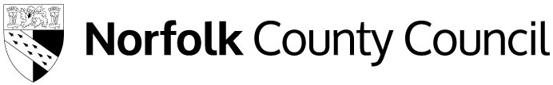

Application form for free school meals from families with no recourse to public funds (NRPF)

Please complete this application form if you are a family with NRPF and would like to apply for free school meals.
To complete this form, applicants should complete all sections.
When completed, please ensure the declaration at the end of the application is also signed.
Further information relating to this extension can be found in the free school meals guidance for schools and local authorities.

Child’s details
Surname of child:
First names(s) of child:
Date of birth of child (dd/mm/yy):
Nationality of child:
Address of child:

Parent/carer’s details
Surname of parent/carer:
First name(s) of parent/carer:
Relationship to child:
Nationality of parent/carer:
Date of birth of parent/carer:
National Insurance or NASS Number:
Address of parent/carer:
What is the immigration category you are applying under? (Please highlight as appropriate):
- Zambrano
- Article 8 of the ECHR
- Section 4 of the Immigration and Asylum Act 1999
- Chen
- BN(O) Passport holder
- Spousal visa holder
- Work visa holder
- Student visa holder
- Other, please explain:

Please provide evidence of immigration status.

Evidence of income
To be eligible for free school meals, your families’ annual household income must be no higher than the following:
- £22,700 for families outside of London with one child
- £26,300 for families outside of London with two or more children
- £31,200 for families within London with one child
- £34,800 for families within London with two or more children
This includes any wider income or support you may be receiving in addition to any earnings from employment. Where possible, please also provide a document to show this – this could be a bank statement, a pay slip or an employment contract.

Are you employed? (Please delete as appropriate):
Yes / No

If you have a partner, are they employed? (Please delete as appropriate):
Yes / No

Is your annual household income, including earnings from employment and any wider support you may be receiving, less than the maximum income thresholds listed above? (Please delete as appropriate):
Yes / No

Declaration of applicant
I (your name):

of (your address):

confirm that the information I have provided above is accurate and true.
I agree that the information I have provided can be shared with the Department for Education for the purposes of assessing eligibility for a free school meal.

Parent/Carer/Guardian with legal responsibility for care of the child
Signature:

Print name:

Date:

Please email the completed application to admissions@norfolk.gov.uk or post to:
Free School Meals, Norfolk County Council, County Hall, Norwich, NR1 2DH

