# Appendix One

## Child/Young Person’s Views

**Tell us about your family, school and friendships**



**What do you enjoy? Who with? What are you good at?**

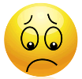

**What do you find difficult? What do you need to help you?**

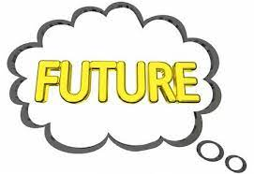

**What are your hopes for the future (think current year/ phase of education/ aims for adult life)**

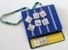**How do you want to be given information? eg talking, signing, pictures, technology**

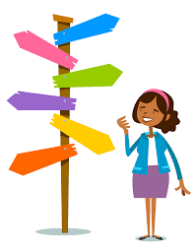

**How can we involve you in decision making and make sure that your choices are listened to and understood?**

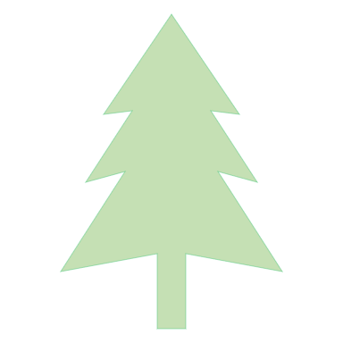

**My aspirations – what do I hope to achieve in the future?**

My aspiration tree

**My outcomes – what will the benefit or difference be from doing this?**

**What do I need to achieve to reach my goal? What will make it easier for me to achieve my outcomes?**

**What do I need to learn?**

**Who can help me?**

**What will help me be healthy?**

**What support is available to me?**

**What help is available for…**

**Learning:**

**Community/support:**

**Health:**

**Independent living:**



**What do I need to learn?**

Extra time on assessments. Customer service skills. Practice on hair. Support in telling the time. How to use money and digital transactions for money. H&S training.

**Who can help me?**

College, family, friends, TITAN course, local salon introduction

**What will help me be healthy?**

Choosing to cook and/or eat healthy foods. Find a type of exercise I enjoy and do it once or twice a week. Choose to walk whenever possible to get around.

**What support is available to me?**

**What do I need to achieve to reach my goal? What will make it easier for me to achieve my outcomes?**

To pass my hair and beauty course. Find a salon near to my home as I do not travel well. I need scissors. I need some work experience. I need contact with members of the public. I need to be helped to travel independently.

**What help is available for…**

**Learning:**

**Community/support:**

**Health:**

**Independent living:**

**My outcomes – what will the benefit or difference be from doing this?**

By the age of 21 I will be working in a hair salon and receiving a wage

**My aspirations – what do I hope to achieve in the future?**

To go to work full time

Example

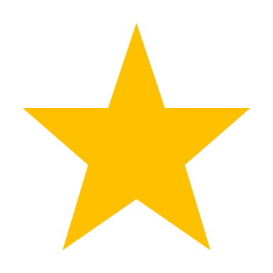

My aspirations

**My aspirations – what do I hope to achieve in the future?**

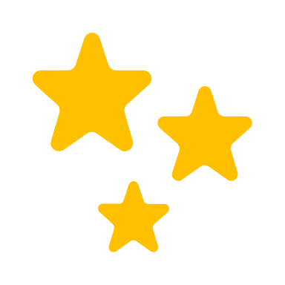



**What help is available for…**

**Learning:**

**Community/support:**

**Health:**

**Independent living:**

**What do I need to learn?**

**Who can help me?**

**What will help me be healthy?**

**What support is available to me?**

**What do I need to achieve to reach my goal? What will make it easier for me to achieve my outcomes?**

**My outcomes – what will the benefit or difference be from doing this?**

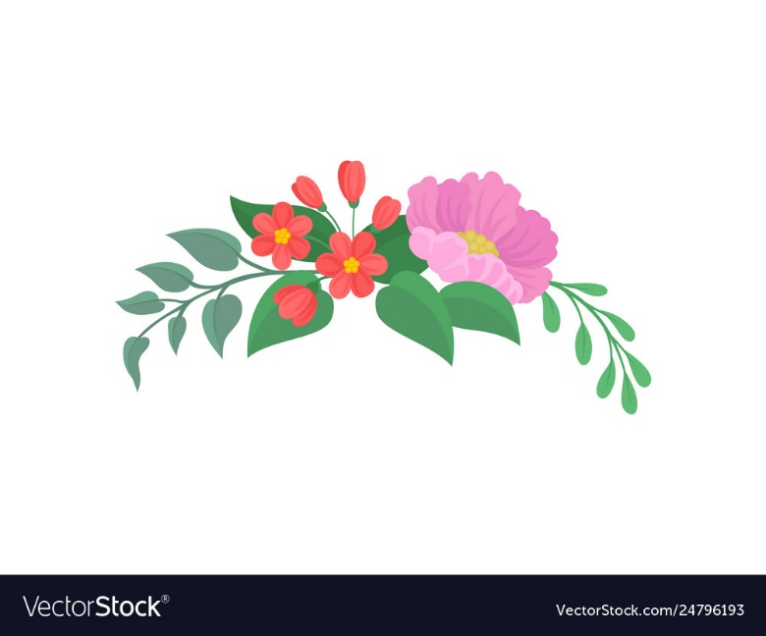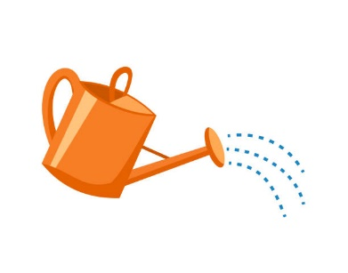

**What help is available for…**

**Learning:**

**Community/support:**

**Health:**

**Independent living:**

**What do I need to learn?**

**Who can help me?**

**What will help me be healthy?**

**What support is available to me?**

**What do I need to achieve to reach my goal? What will make it easier for me to achieve my outcomes?**

**My outcomes – what will the benefit or difference be from doing this?**

**My aspirations – what do I hope to achieve in the future?**

My aspirations

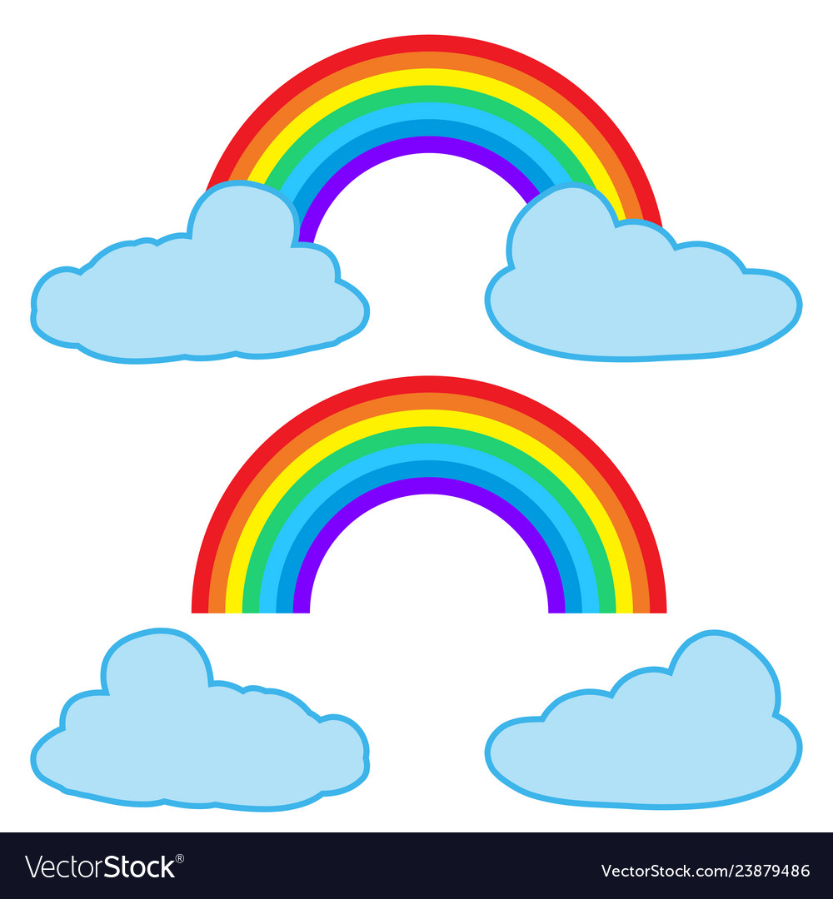

**What help is available for…**

**Learning:**

**Community/support:**

**Health:**

**Independent living:**

**What do I need to learn?**

**Who can help me?**

**What will help me be healthy?**

**What support is available to me?**

**What do I need to achieve to reach my goal? What will make it easier for me to achieve my outcomes?**

**My outcomes – what will the benefit or difference be from doing this?**

**My aspirations – what do I hope to achieve in the future?**

My aspirations

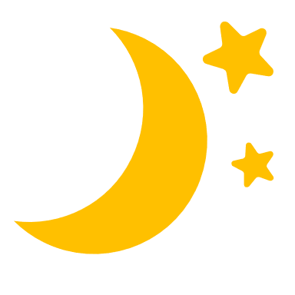

My aspirations

**My aspirations – what do I hope to achieve in the future?**

**My outcomes – what will the benefit or difference be from doing this?**

**What do I need to achieve to reach my goal? What will make it easier for me to achieve my outcomes?**

**What do I need to learn?**

**Who can help me?**

**What will help me be healthy?**

**What support is available to me?**

**What help is available for…**

**Learning:**

**Community/support:**

**Health:**

**Independent living:**

**What help is available for…**

**Learning:**

**Community/support:**

**Health:**

**Independent living:**

**What do I need to learn?**

**Who can help me?**

**What will help me be healthy?**

**What support is available to me?**

**What do I need to achieve to reach my goal? What will make it easier for me to achieve my outcomes?**

**My outcomes – what will the benefit or difference be from doing this?**

**My aspirations – what do I hope to achieve in the future?**

My aspirations

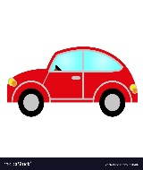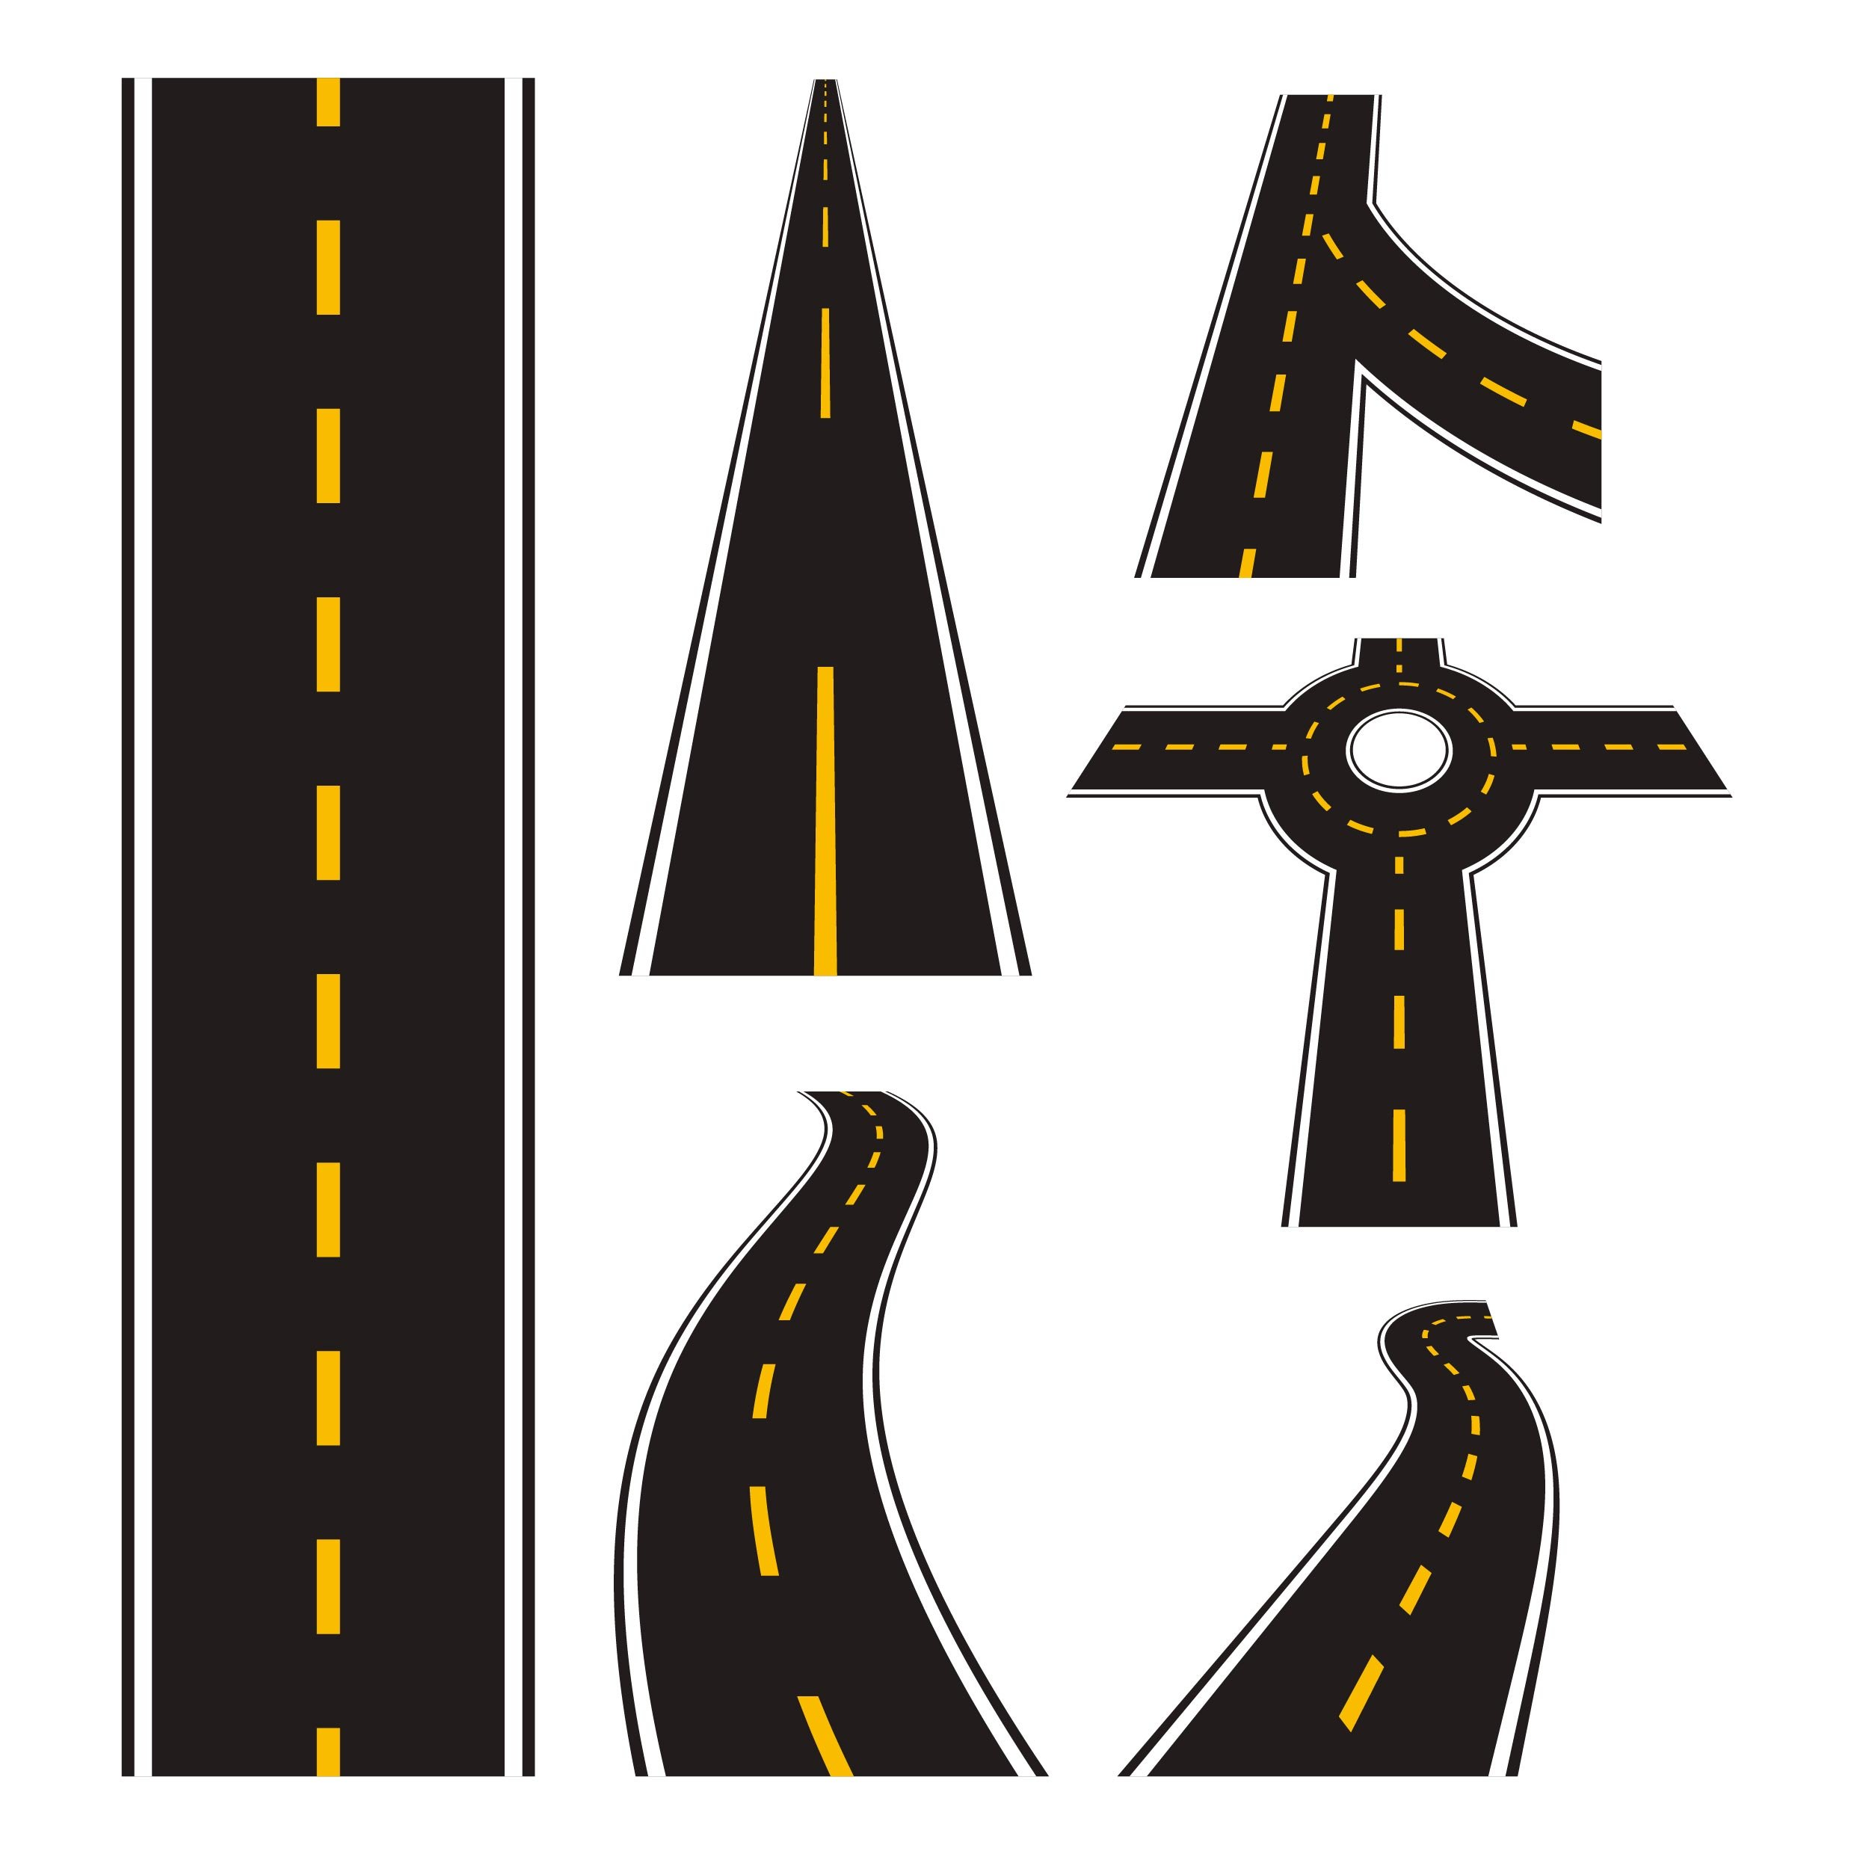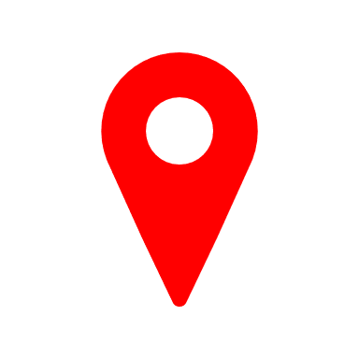

My aspirations



**What help is available for…**

**Learning:**

**Community/support:**

**Health:**

**Independent living:**

**What do I need to learn?**

**Who can help me?**

**What will help me be healthy?**

**What support is available to me?**

**What do I need to achieve to reach my goal? What will make it easier for me to achieve my outcomes?**

**My outcomes – what will the benefit or difference be from doing this?**

**My aspirations – what do I hope to achieve in the future?**

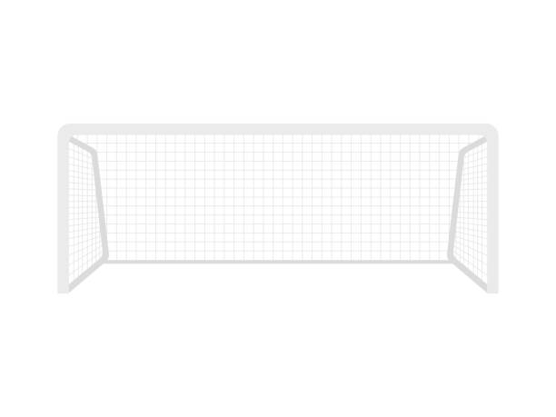

My aspirations and goals

**My aspirations – what do I hope to achieve in the future?**

**My outcomes – what will the benefit or difference be from doing this?**

**What do I need to achieve to reach my goal? What will make it easier for me to achieve my outcomes?**

**What do I need to learn?**

**Who can help me?**

**What will help me be healthy?**

**What support is available to me?**

**What help is available for…**

**Learning:**

**Community/support:**

**Health:**

**Independent living:**





**My aspirations – what do I hope to achieve in the future?**

**My outcomes – what will the benefit or difference be from doing this?**

**What do I need to achieve to reach my goal? What will make it easier for me to achieve my outcomes?**

**What do I need to learn?**

**Who can help me?**

**What will help me be healthy?**

**What support is available to me?**

**What help is available for…**

**Learning:**

**Community/support:**

**Health:**

**Independent living:**

My aspirations and goals



My aspirations and goals

**My outcomes – what will the benefit or difference be from doing this?**

**What do I need to achieve to reach my goal? What will make it easier for me to achieve my outcomes?**

**What do I need to learn?**

**Who can help me?**

**What will help me be healthy?**

**What support is available to me?**

**What help is available for…**

**Learning:**

**Community/support:**

**Health:**

**Independent living:**



**My aspirations – what do I hope to achieve in the future?**