Application for Advisory Access Marking

Applicant’s details
Title (Mr / Mrs / Miss / Ms etc.):

Full name:

Address:

Postcode:

Main telephone number:

Alternative telephone number:

Email address:

Address where the marking is required (if different from above):

Postcode where the marking is required (if different from above):

Do you already have a legal access to the property? (delete as appropriate)
Yes / No

Charges

The cost of applying for and supplying an “H” bar depends on the width of markings required. To provide additional markings there is a minimum charge of £142.44 based on a standard 3m entrance (inclusive of a £71.22 assessment charge) plus £23.74 per linear metre thereafter. You will be sent a quotation of the exact amount if and when the application is approved.

By confirming you wish to go ahead with the application you are agreeing to the notes and conditions enclosed.

If you require a longer entrance marking please specify here how long you need your entrance marking to be, in metres:

For shared driveways or crossover only

If you share your dropped kerb with a neighbour, you will require their permission for the white “H” bar to be installed.

Other owner’s details

Full name:

Address:

Postcode:

Main telephone number:

Signature:

Proposed site layout

We require an image specifying the layout, position, and dimensions of the proposed “H” bar marking. You may provide a detailed plan (see Figure 1 as an example), or a photograph (see Figure 2 as an example). Please draw a line labelled ‘a’ for the start and ‘b’ for the end of the proposed “H” bar.
If you choose to draw a plan, please ensure that it includes lamp columns, manholes, watercourses and other similar obstructions. Please draw the layout as viewed from above the property.

Examples
Figure 1
Image below is a road map, zoomed in to an address. It shows the location of the property's driveway, carriageway, dropped kerbs, and footway crossing in relation to each other, and specifies where the proposed "H" bar should go. The letters 'a' and 'b' are displayed in bold red font to specify the start and end of the proposed "H" bar.
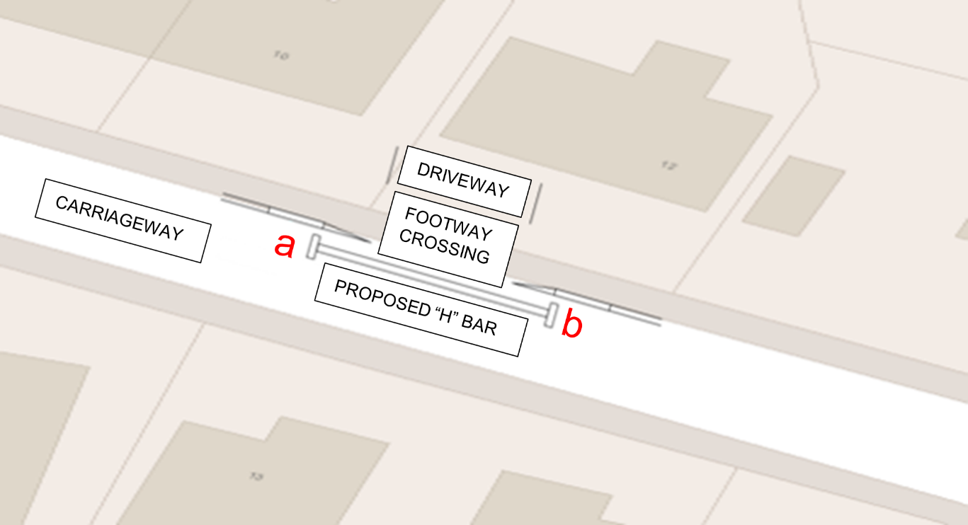

Figure 2
Image below is a photograph of a road. It shows the proposed location of the “H” bar in white. The letters 'a' and 'b' are displayed in bold red font to specify the start and end of the proposed "H" bar.
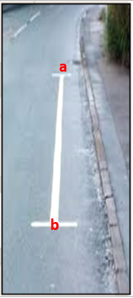

Please insert your labelled plan or photograph here:

Declaration

I hereby request Norfolk County Council to introduce this advisory road marking in accordance with the notes and conditions attached on pages 6-7, which I have read carefully and accept fully.

Signature:

Print name:

Date:

Privacy Notices and GDPR

Please visit our website at www.norfolk.gov.uk/gdpr to view our privacy notices and your rights under GDPR.

Please return the application form via email or post using the details below.

Email: highwayworks@norfolk.gov.uk

Postal address:
Norfolk County Council
Community and Environmental Services
County Hall
Martineau Lane
Norwich
NR1 2SG

Telephone enquiries: 0344 800 8020

Office Use Only

Date application received:
Investigating Officer:
Payment received (delete as appropriate): Yes / No
Date of payment:
Approved (delete as appropriate): Yes / No
Date:
Date implemented:

Notes and conditions on applications for advisory access markings

1. The purpose of this road marking is to indicate part of the carriageway outside an entrance to off-street premises or a private drive, or where the kerb is dropped to provide a convenient crossing place for pedestrians, which should be kept clear of waiting vehicles.

2. The decision to approve or reject your application for an “H” bar road marking is made entirely at the discretion of Norfolk County Council. Completion of the application form does not guarantee that a marking will be provided. Examples include wide dropped kerbs spanning several properties, and locations where parking restrictions such as yellow lines already exist.

3. A fee is associated with an advisory white “H” bar. The proposed charge would be £71.22 per application and a further:
- £71.22 for a 3m length “H” bar
- £94.96 for a 4m length “H” bar
- £142.44 For a 6m length “H” bar
- Completion of lining works is subject to staff and contractors’ availability and workload, and factors beyond the control of Norfolk County Council such as weather conditions. The council shall not be held liable for delays arising from these or similar factors.

- After we receive your payment, it takes about 12 weeks to process an application and then a further 12 weeks to arrange implementation on street. Where possible we will try to complete the process sooner.

6. If your “H” bar line fades or becomes broken you can ask us to repaint it, based on the current cost for this work.

7. We cannot provide these markings if the kerb has not been dropped for the purpose of vehicle access to private property.

8. If the dropped kerb extends across two driveway entrances, you are required to obtain written consent from your neighbour. The applicant is responsible for the full cost of the application.

9. Misuse of an “H” bar marking may result in its removal. In such circumstances there will be no refund of any payments made.

10. The markings would be guaranteed for 1 year, during which they would be included in our routine inspections and any reapplication would be free of charge. After this period there would be no further maintenance and if the householder wanted the “H” bar lines to be renewed a new application would be required.

This document is version 4.

